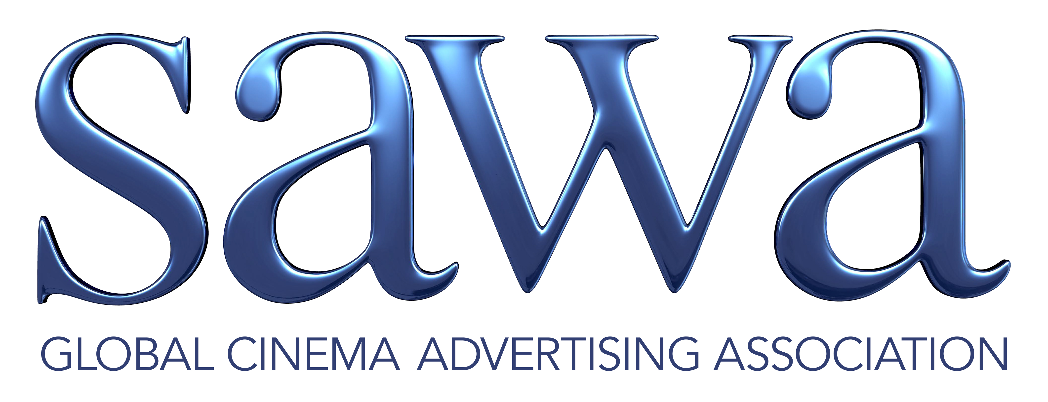

TECHNICAL AND CREATIVE REQUIREMENTS FOR DIGITAL 3D CINEMA.

There are numerous technical and creative specs for Digital 3D cinema. The first and most important specification is: don’t hurt their eyes! Digital 3D spots should be created by pros that understand stereoscopy and are able to take full advantage of the beauty and wonder of 3D without causing eyestrain on the viewers. By the time the exhibitors get the files, it is too late to deal with inherent technical or creative problems.

First, the technical specs. These may vary from exhibitor to exhibitor so check with your local cinemas to ensure server and projection system compatibility.

PICTURE REQUIREMENTS FOR 3D DCP CREATION

1. Original content should be created in HD resolution
2. Files should be delivered as 16 bit TIFF / 10 bit DPX Files as two separate & discreet file sequences on a single Hard Drive.
3. Each eye must be clearly identified in two folders: “Left_Eye” / “Right_Eye”
4. Left eye and right eyes must have the same number of files and be in sync with each other.
5. File resolution should be 1920x1080
6. Color Space should be Rec 709
7. Frame Rate should be 24 fps per eye per second
8. Files naming convention should be labeled as follows: spotname3D_left__scope or flat_eng or fre _0001.tiff
spotname3D_right__scope or flat_eng or fre _0001.tiff
9. Please indicate if you are delivering a flat 1.85:1 image or a scope 2.35:1 image size.

ALL spots delivered should have: 10 frames slate, 10 frames black, 2 beep, followed by 47 frames black, followed by first frame of picture. (The “2 beep” is one frame of 1khz tone placed 2 seconds ahead of first frame of picture).

AUDIO REQUIREMENTS FOR 5.1 DOLBY MIX

1. Audio can be delivered on a CD, DVD, or Protools session.
2. Please deliver full 5.1 mix stems with the following track assignments – Left, Right, Centre, Left Surround, Right Surround, & Sub. The tracks should be fully labeled.
3. If a stereo mix is your only source, your 2 track mix can be “cheated’ into a full Dolby 5.1 mix.
4. All sound files should be Broadcast 24-bit WAV format in a Sample rate of 48KHZ at 24fps
5. The “2 beep” is one frame of 1khz tone placed 2 seconds ahead of first frame of picture.

CREATIVE REQUIREMENTS

From a creative point of view, the content of the 3D spot should be “easy on the eyes”. Objects that come off the screen or into “Negative Parallax” should be limited. Objects or textures in the background or “Positive Parallax” should be offset by a measurement of less that 3% of the screen width. I.e. if you are looking at an image on a 42” screen, the offset images should not be offset by more than 1.25 inches. It sounds complicate but really is not. Make sure the creative agency had done their 3D homework and the results will be mesmerizing!

