BrandScience presented the European findings for SAWA (Global Cinema Advertising Association) in 2012.
Highlights included strong returns for Cinema in the FMCG market relative to other media:
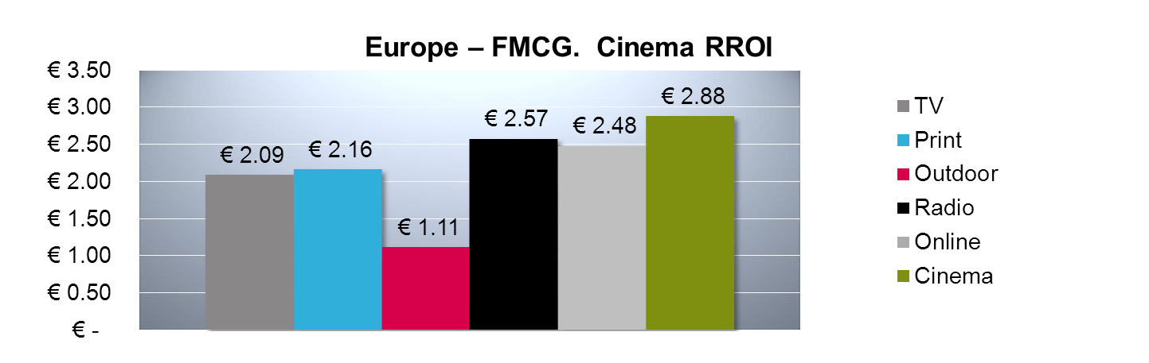
As well as a clear indictment for the use of Cinema in the FMCG subcategory, Food & Drink:
